**Pookas ETventure**

**DESIGN DOCUMENT**

**V 1.1**

# Revision History

|  |  |  |  |
| --- | --- | --- | --- |
| Revision Number | Date | Primary Author(s) | Comments |
| 1.0 | 10 Sep 2009 | Ivan Loh, Sarah Lam, Gillian Ng Lui Quan Fu, Goh Li-Xian | First Version |
| 1.1 | 05 Oct 2009 | Ivan Loh, Sarah Lam, Gillian Ng Lui Quan Fu, Goh Li-Xian | Refined Design Document |

# 1 Design Specifications

Pooka’s Edventure is an extension of the current virtual classroom in Active World. It includes extra features such as having virtual lectures with professors, a game quiz, a message board and also teleporting stations.

The virtual lectures are held in LT1A . The user avatar can walk towards the Professor in front of the LT, and interact with the professor. This means to say that the professor is 3D in nature. After one exchange (user avatar asks for a topic in the course he is enrolled in and the professor replies) with the professor, the requested topic will be provided with powerpoint slides pulled from Edventure.sg and projected onto the screen and/or side browser in Active World

Games quizzes are held in Level 2 of the NTU Virtual Building, just outside of LT1A. Again there would be a projection screen displaying the various MCQ questions and 4 tiles representing A,B,C and D will enable the user avatar to answer the questions simply by walking to either of these tiles. For e.g. if the user avatar thinks that the answer to the question is A, he will walk towards the tile representing A.

Students who are enrolled in the same courses in Edventure can pose questions or hold discussions on the message board. All questions and discussions are broadcasted to students in that course. Lecturers are also able to broadcast announcements or hold discussions with students who are in the course he is lecturing.

Due to the vastness of the virtual classroom, teleporting stations are placed within strategic locations enabling user avatars to go from place to place with ease. The avatar simply walks towards the teleporting point and once he’s inside, he will be teleported to another teleporting point.

**Additional Notes**

**Lecturer Bot**

The bot gets announcements from Edventure. Latest announcement is broadcasted to user upon their login. Older announcements have to be viewed by talking to the lecturer bot. Users talk to the lecturer bot, which gives answers based on AIML.

**Quiz**

1. User A talks to quiz bot to start the quiz game in the virtual classroom.
2. Quiz bot notifies users that a quiz is going to begin – AddPlayer()
3. Users talk to quiz bot to participate in the quiz - AddPlayer()
4. Quiz bot retrieves a question, and starts the first round after x amount of time - StartRound()
5. players walk to each tile/bump into each quiz panel denoting which answer they picked and Quizbot Quiz bot counts down x seconds to the end of the round - Tick() function.
6. When the time is up, EndRound() is called to verify player’s answers and promote/demote their y-positions.
7. Players can choose to leave the game between rounds, but no additional players are allowed to join.
8. After x amount of time, next question given to remaining players.
9. After a certain number of questions, the quiz is over, all players removed, Destroy() function called

# 2 Class Diagram

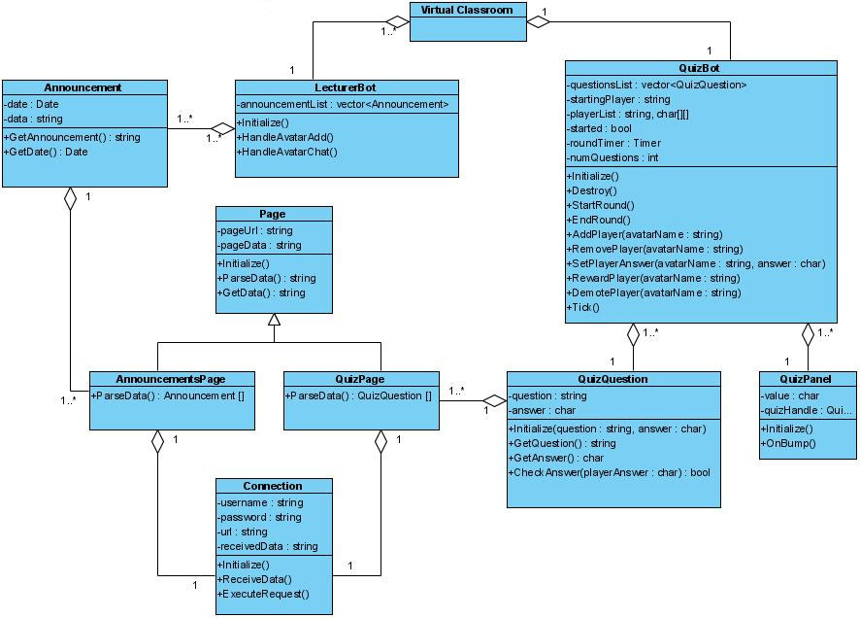

Figure - Class Diagram

# 3 Activity Diagram

Login

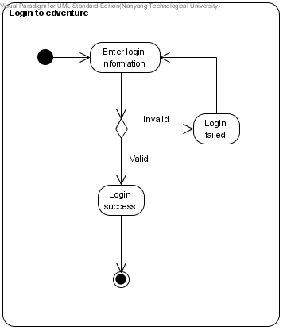

Fig 2 – Login to Edventure Activity Diagram

Participate in game quiz

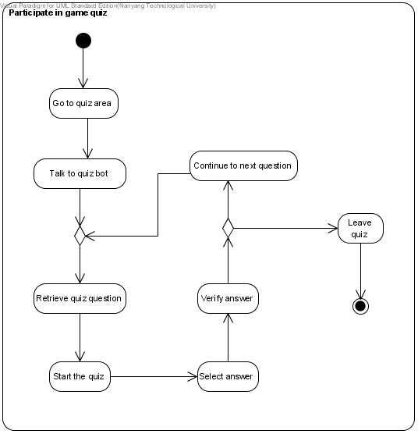

Fig 3 – Participate in Game Quiz Activity Diagram

Teleport Around

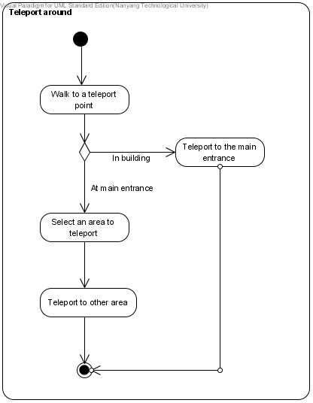

Fig 4 – Teleport Around Activity Diagram

View Announcement

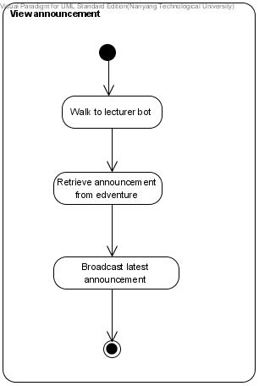

Fig 5 – View Announcement Activity Diagram

Broadcast Message

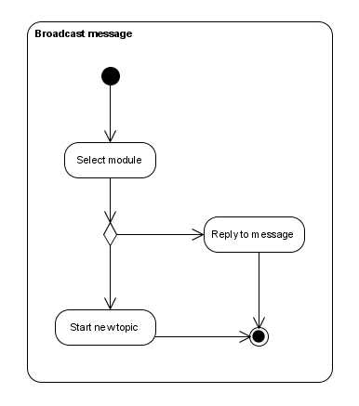

Fig 6 – Broadcast Message

Attend Virtual Lectures

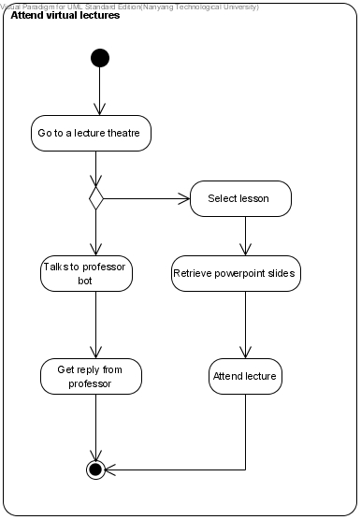

Fig 7 – Attend Virtual Lectures

Talks to Lecturer Bot

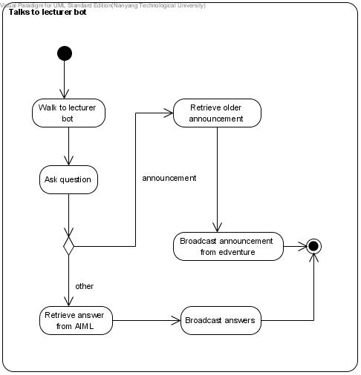

Fig 8 – Talks to Lecturer Bot

# 4 State Diagram

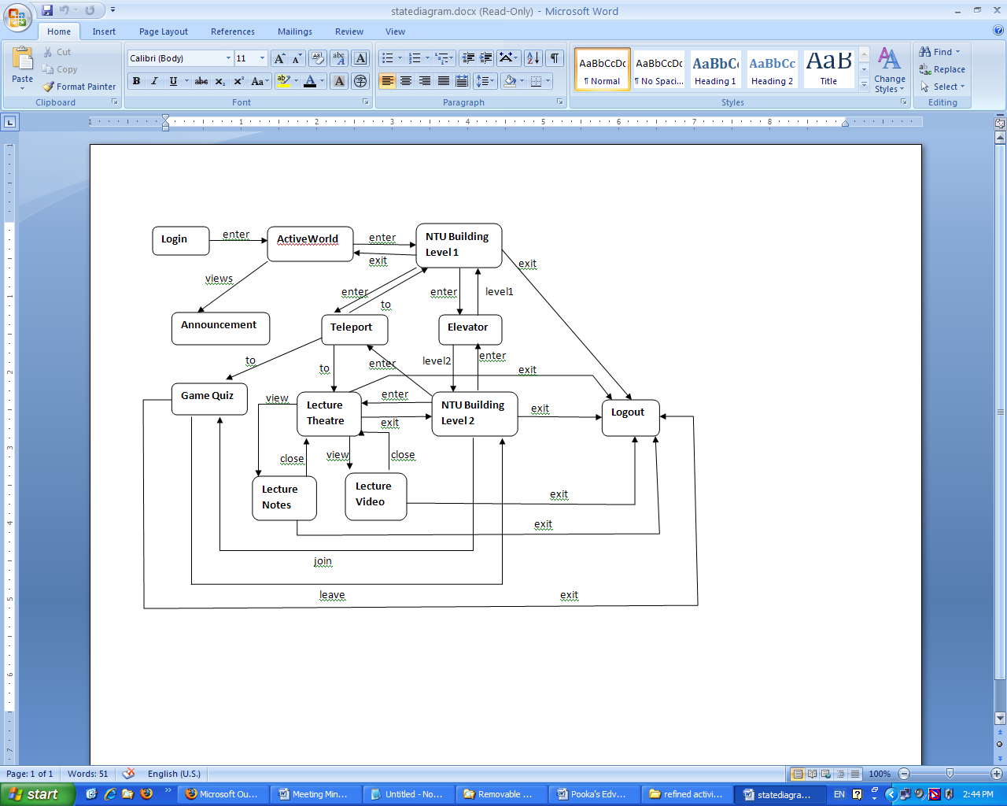

Figure 9 - State Diagram

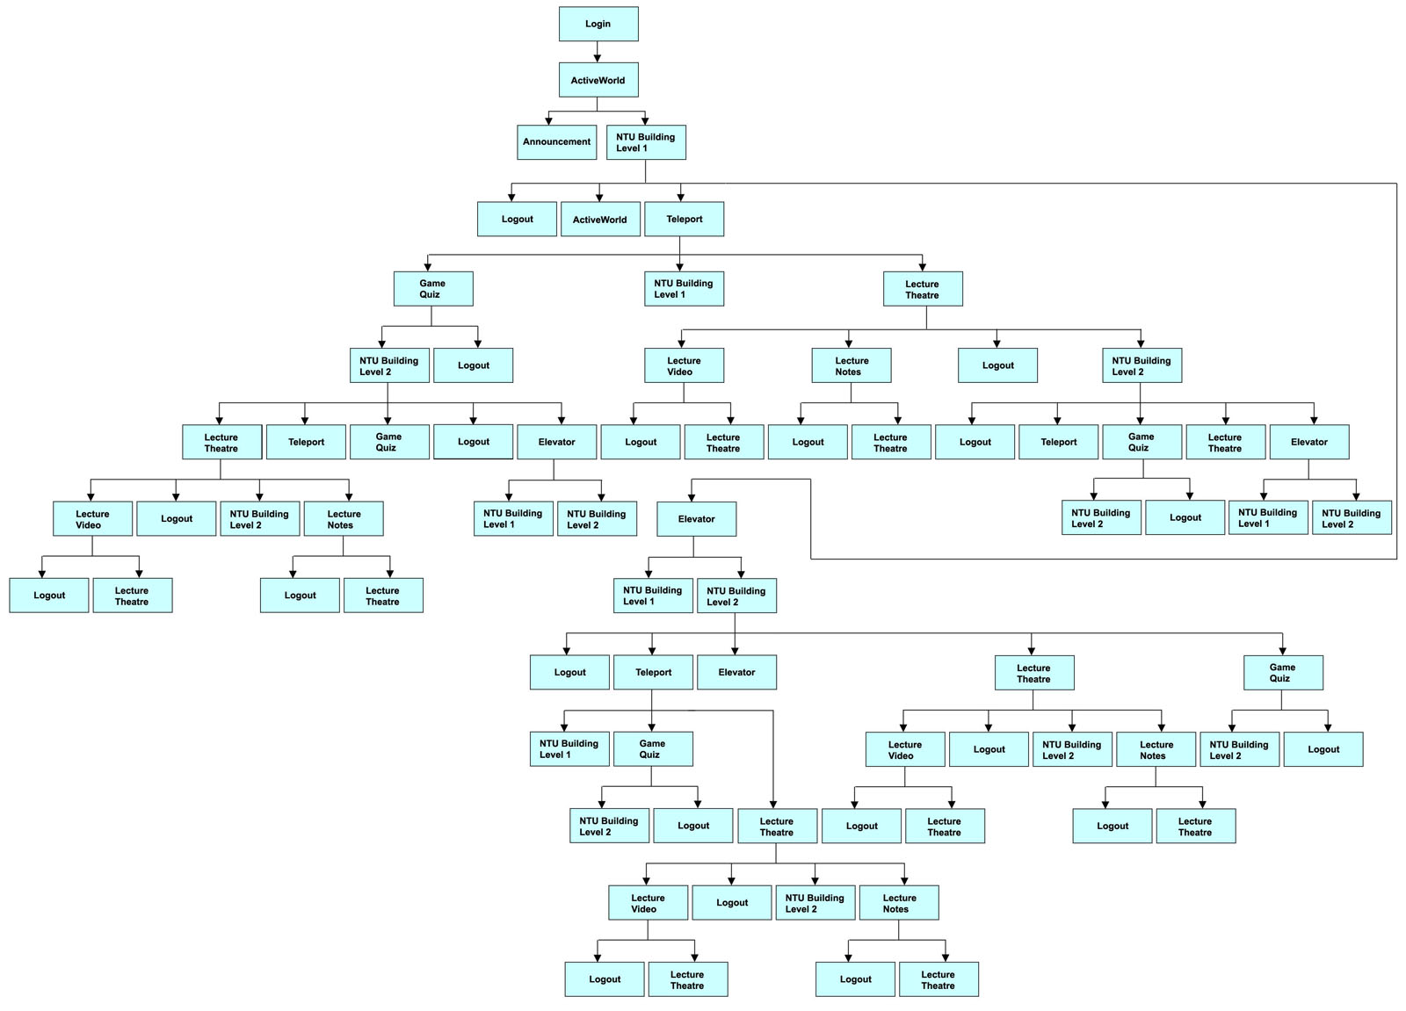**4.1 Transition Tree**

# 4 Virtual World Screenshots

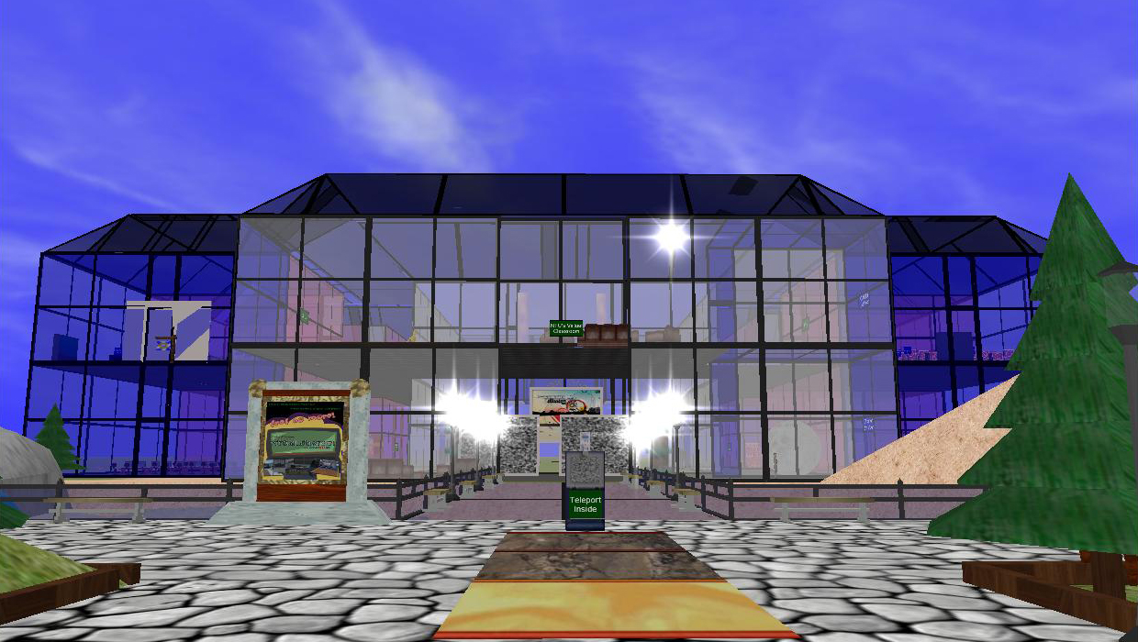

Figure 2- Front view of the virtual world. Teleport points are created for quick access around the world.

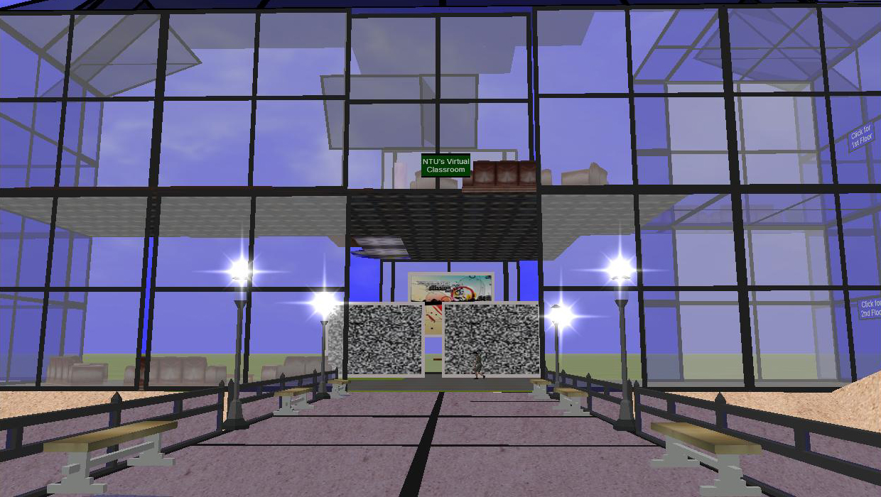

Figure -Main entrance to the virtual classroom.

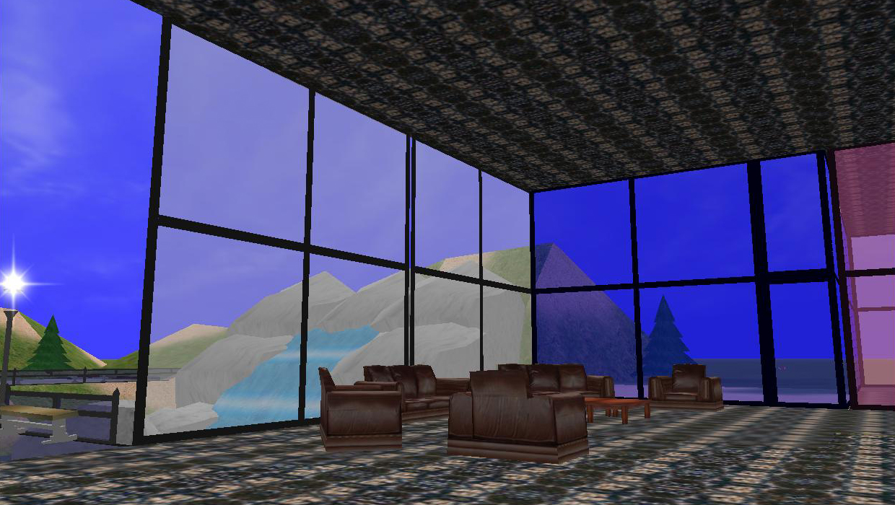

Figure - Sofa area in the main lobby.

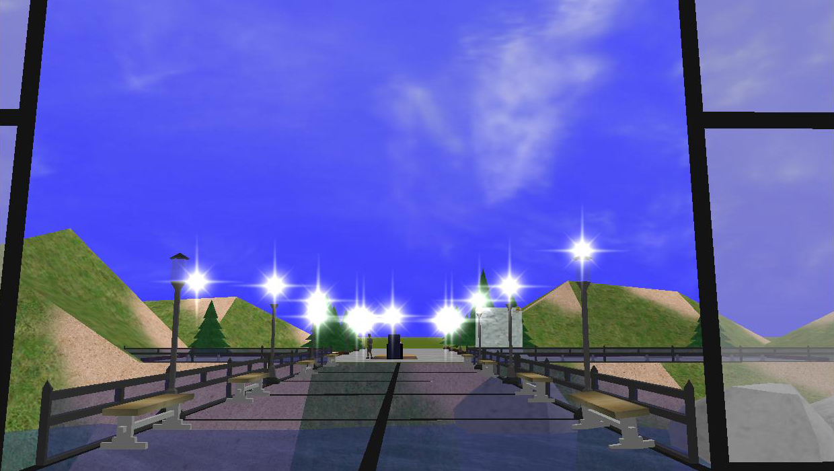

Figure - Outside view from the building.

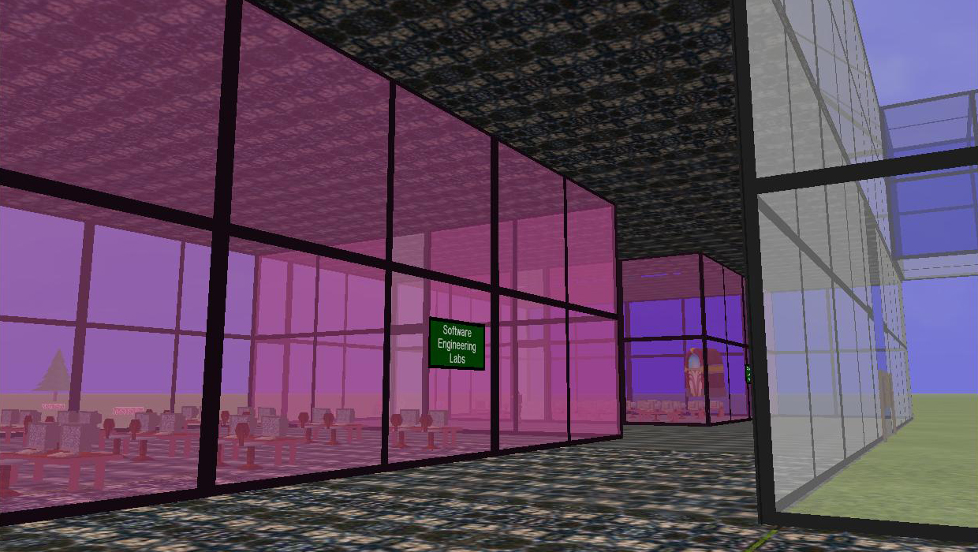

Figure - Labs and tutorial rooms are located in level 1 of the building.

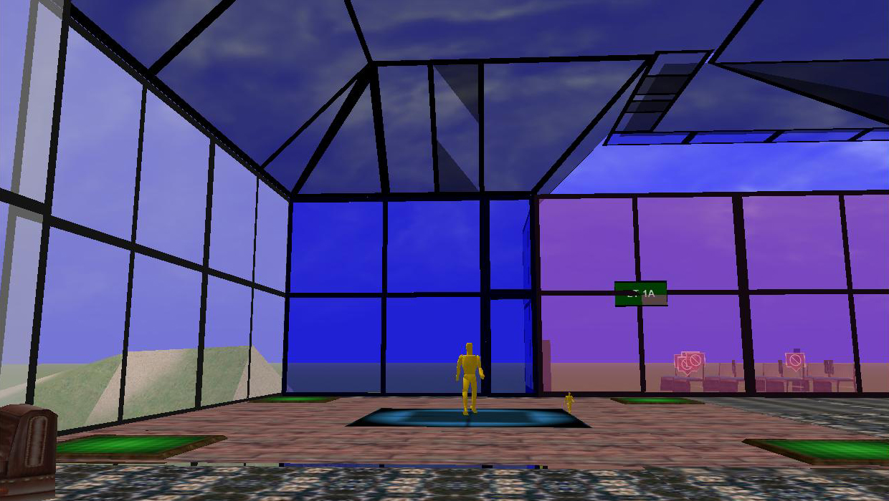

Figure - Students can participate in game quizzes on level 2 of the virtual classroom.

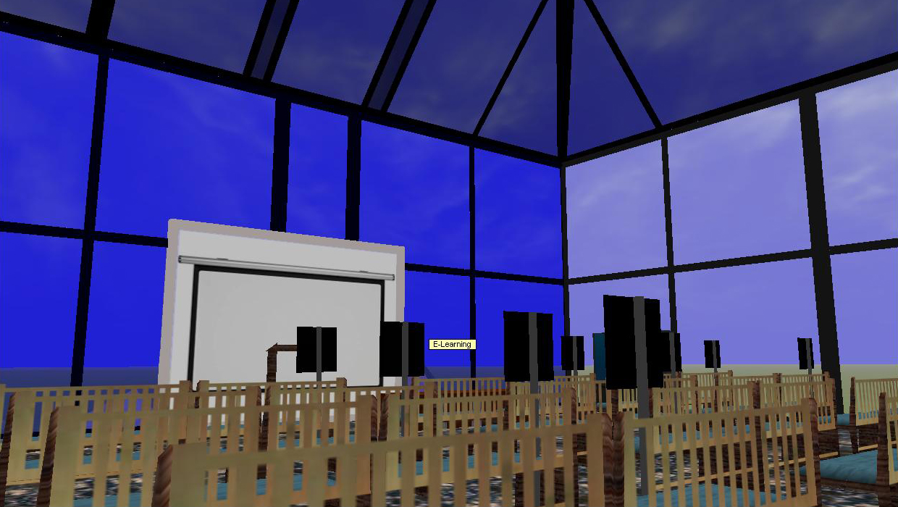

Figure - Inside view of a lecture theatre. Lecture theatres are found in level 2.